M1: Assignment - Lane Dorscher
Part 1 – SQL Server installation
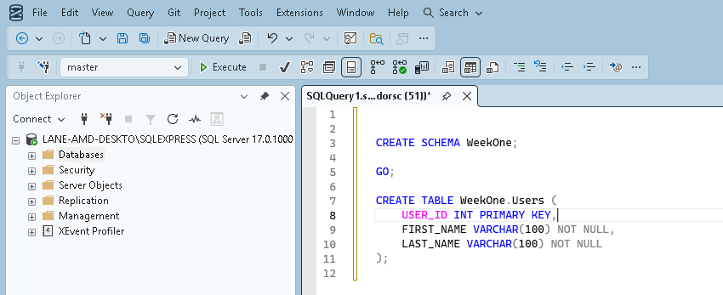
Part 2 – Translating ERD into business rules.
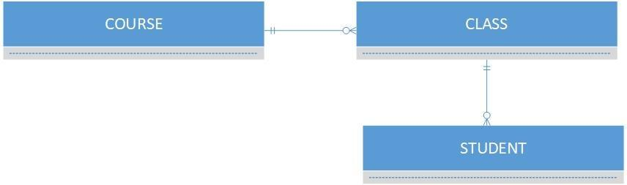

This Entity Relationship Diagram or ERD showcases 3 tables Course, Class, and Student. The relationship line drawn between them shows that a single course may have multiple classes with each class only having one course. A class may have many students enrolled in which the student can only be enrolled in that class once
In summary:
- One Course can have many Classes, but each Class belongs to only one Course.
- One Class can have many Students, but each Student is enrolled in a given Class only once.

